Creating a poetic world
Through this exercise students get an understanding of how detailed use of language can open-up new meaning and start to see why writers use the language they do to convey a meaning.

Getting Started - as a class...
Read: If All The World Were Paper by Joseph Coelho

If all the world were paper

If all the world were paper
I would fold up my gran and take her everywhere I go.
I would laminate my baby sister in bubble wrap
and lay her to sleep in unbound fairy-tale book pages
and should she get scared:
Rip every fear,
Shred every scream,
Tear every tear.

If all the world were paper
I would re-bind my grandfather,
smooth out the dog-ears to all his stories,
place his younger days in a zoetrope
and flush the harrowing chapters
down an ink-gurgling well.

If all the world were paper,
kind deeds would be post-it notes
that stuck to the doer in ever growing trails,
so we would always remember,
friends would come with perforated lines
so you could keep their best bits with you at all times.

If all the world were paper,
Christmas wrapping foil and birthday cards
would follow you to school.

If all the world were paper
dreams would be Braille
so we could read them whilst we slept,
nightmares would be shopping lists
because shopping lists are so easy to forget.

If all the world were paper
arguments would rustle before they started
and could be put right with a little tape.

If all the world were paper
we could paperclip families together,
draw smiles on all the sad faces,
rub out the tears,
cover our homes in Tipex and start all over again.

All the world is not paper
but whilst we can imagine it were
we can recycle the rough times
knowing we will never - ever fold.

© Joseph Coelho 2006
A version Published in “The Works 6” Macmillan Ed. Pie Corbett 2007

Discussion
What is the poem about? What is the theme of the poem? What does the poet feel about family? How do we know? What poetic devices are used? What are the impact of these devices on you the reader? Is everything in this world made of paper?

Individual work
Creating a Spider Diagram
Whilst writing this poem I drew a Spider Diagram of things associated with paper and used this as a bank of ideas to include in the poem. Get the students to create a spider diagram for something else that the world could be made of.

Working with a theme
I wanted to write a poem about family but by using the language of paper, so I also drew a spider diagram on the theme of family. Get the class to create a second spider diagram for a theme, it might be emotions, friendship, injustice, school anything you like.

Making connections
Make connections between the spider diagrams to get ideas for new sentences. The link i made between my spider diagrams inspired my first line...

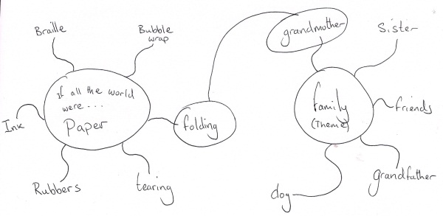

Writing
Ask students to write their poems being particularly aware of the consequences of their decisions for their worlds i.e. the impact on teeth in a world of sweets. Ask them to consider how they will structure their poem. Who or what rules their world? What do emotions look like in their world? What could they do to a bad day in their world? How would they pay for things in their world?

Possible Extensions
Once written students can read their poems out aloud and have other students ask them questions of their worlds. This can provide more material for students to use in a second draft of the poem.

Poet's Tip
Encourage students to use the associations on their Spider Diagrams and to avoid the idea that in a world of chocolate everything is made of chocolate - it isn't everything is ASSOCIATED with chocolate.

